# ACTIVITY 1 - Introduction (Reviews and Sentiment Value)

The persuasive power of words can be seen in a variety of places such as entertainment, news, social media, and even reviews and comments. This activity focuses on the sentiment value of individual words, and you will start by reading a few online reviews of your choice.

1. In this activity you’ll be calling the sentimentVal method. Find this method in the Review class and answer the following questions:
   1. Record the method signature in the space below.

|  |
| --- |

* 1. Does this method require a parameter? If so, what type of parameter is required? What happens if you pass a different type of parameter instead? (Try it!)

|  |
| --- |

* 1. Does the method return a value? If so, what is the return type?

|  |
| --- |

1. Write code that tests the sentimentVal method by calling it with several different String parameters and printing out the return value. Any words not in the list will have a return value of zero. Make sure to keep calling the method until you have at least three strings that have a return value other than zero. Record the method calls, including provided strings and return values in the chart below:

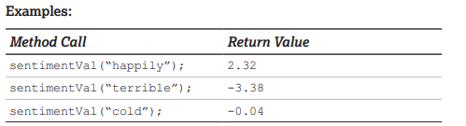

| **Method Call** | **Return Value** |
| --- | --- |
|  |  |
|  |  |
|  |  |

Open up the cleanSentiment.csv file and look up a few of the words that were used in the method call to verify the results.

## Check Your Understanding

1. Determine whether or not each statement would compile. Briefly justify your answers.
   1. double num = sentimentVal(“warm”);

|  |
| --- |

* 1. String word = sentimentVal(0.5);

|  |
| --- |

* 1. double x = sentimentVal(“good”, “bad”);

|  |
| --- |